**Question 1**

**Time series graph for weekly changes:**

Graph 1: FFDIF VS TIME Graph 2: TB03DIF VS TIME

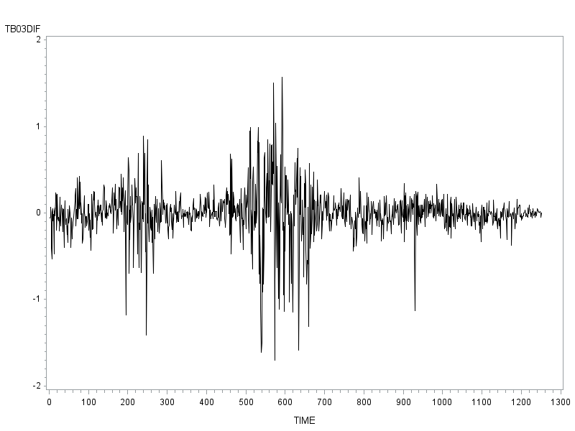

P1

P2

P3

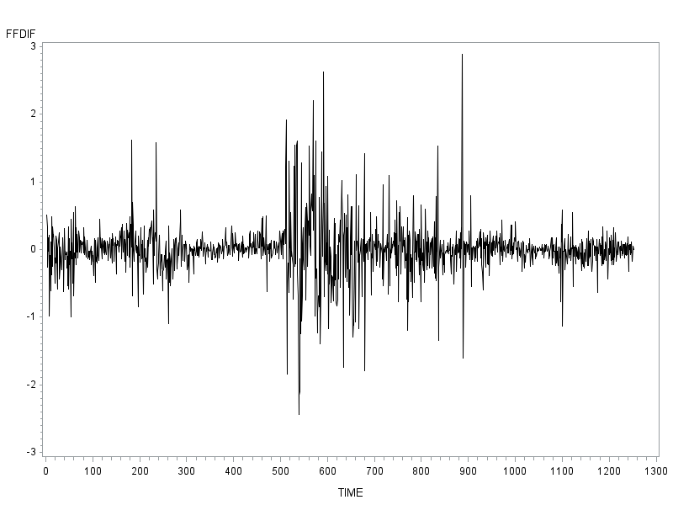

P1

P2

P3

Graph 3: CM10DIF VS TIME Graph 4: AAADIF VS TIME

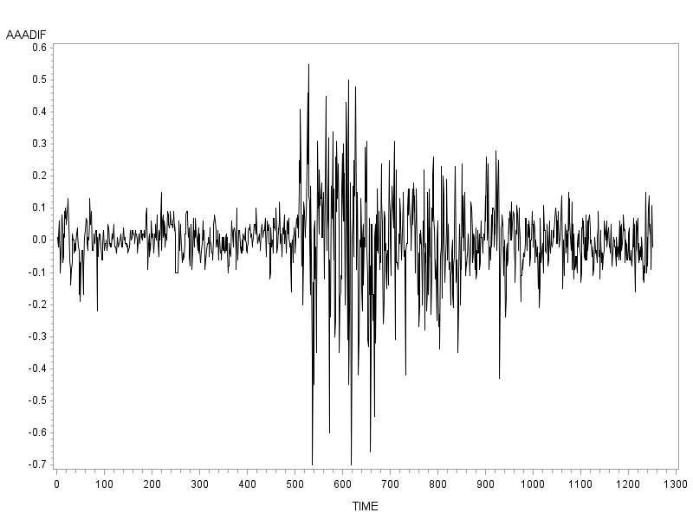

P2

P3

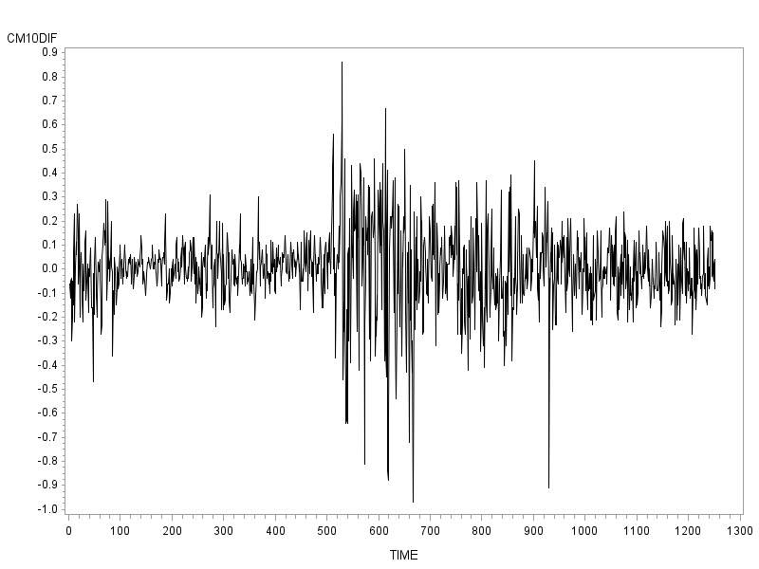

P2

P3

In general, dif(FF) and dif(TB03) have less amplitude than dif(CM10) and dif(AAA). Three highly volatile regions, P1, P2, and P3, can be identified: P2 and P3 are observed in all graphs, while effect of P1 is only present in Graph 1 and Graph 2.